## Problem 1

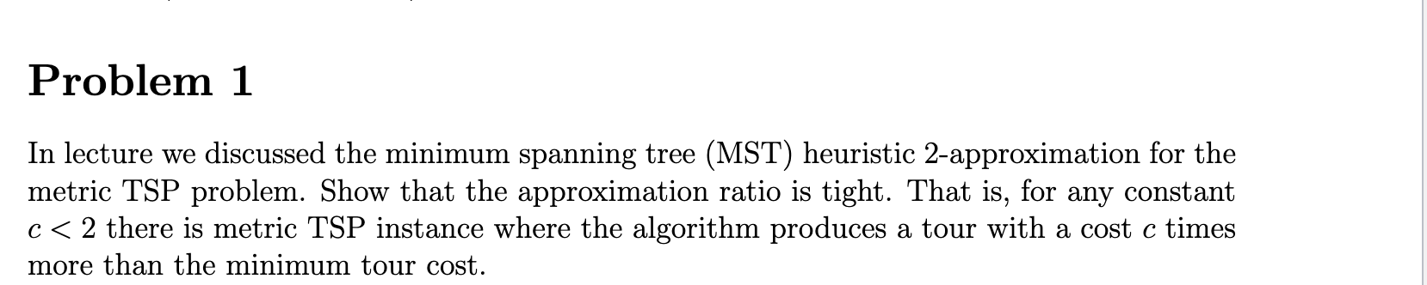

To show that the approximation ratio of the MST heuristic 2-approximation for the metric TSP problem is tight, we need to construct a metric TSP instance where the algorithm produces a tour with a cost exactly twice the minimum tour cost.

Consider a graph with three vertices: A, B, and C. Let the distances be as follows:

* d(A, B) = d(B, C) = 1
* d(A, C) = 2

The minimum spanning tree (MST) of this graph is the tree with edges AB and BC, which has a total cost of 2.

The MST heuristic constructs a tour by doubling the MST and taking a walk around the resulting multigraph. In this case, the tour would be A -> B -> C -> B -> A, which has a total cost of 4.

The optimal tour for the TSP problem on this instance is A -> B -> C -> A, which has a total cost of 2.

Therefore, for this instance, the MST heuristic produces a tour with a cost exactly twice the minimum tour cost. This shows that the approximation ratio of 2 for the MST heuristic is tight. For any constant c < 2, we can always construct a similar TSP instance where the MST heuristic produces a tour with a cost more than c times the minimum tour cost. Hence, the approximation ratio is indeed tight.

## 

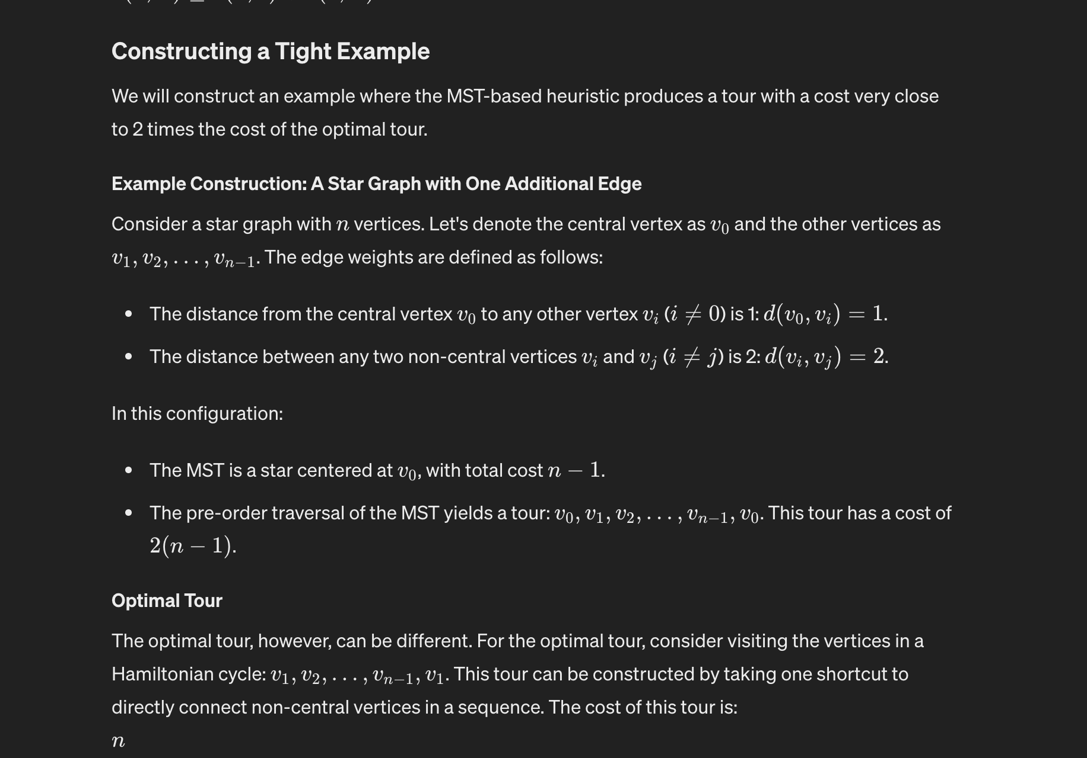

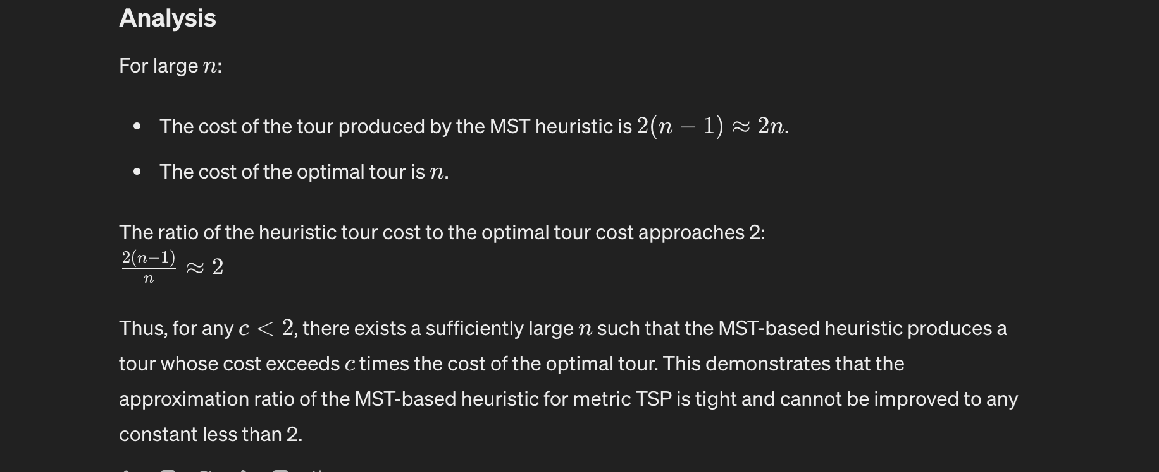

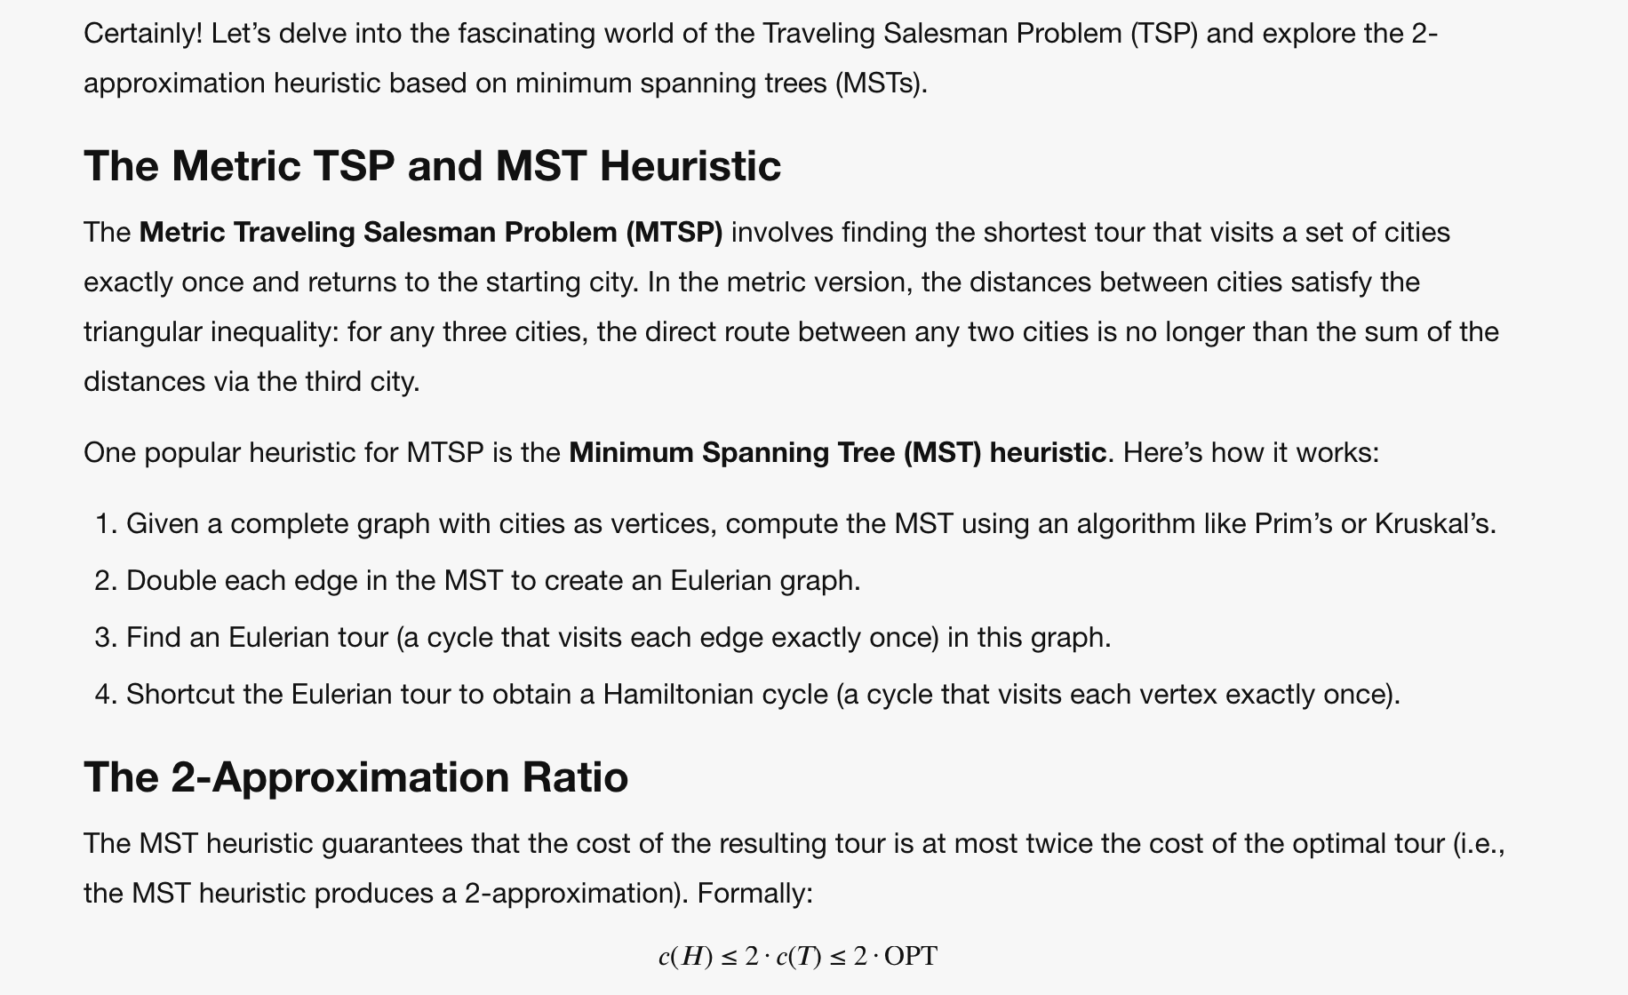

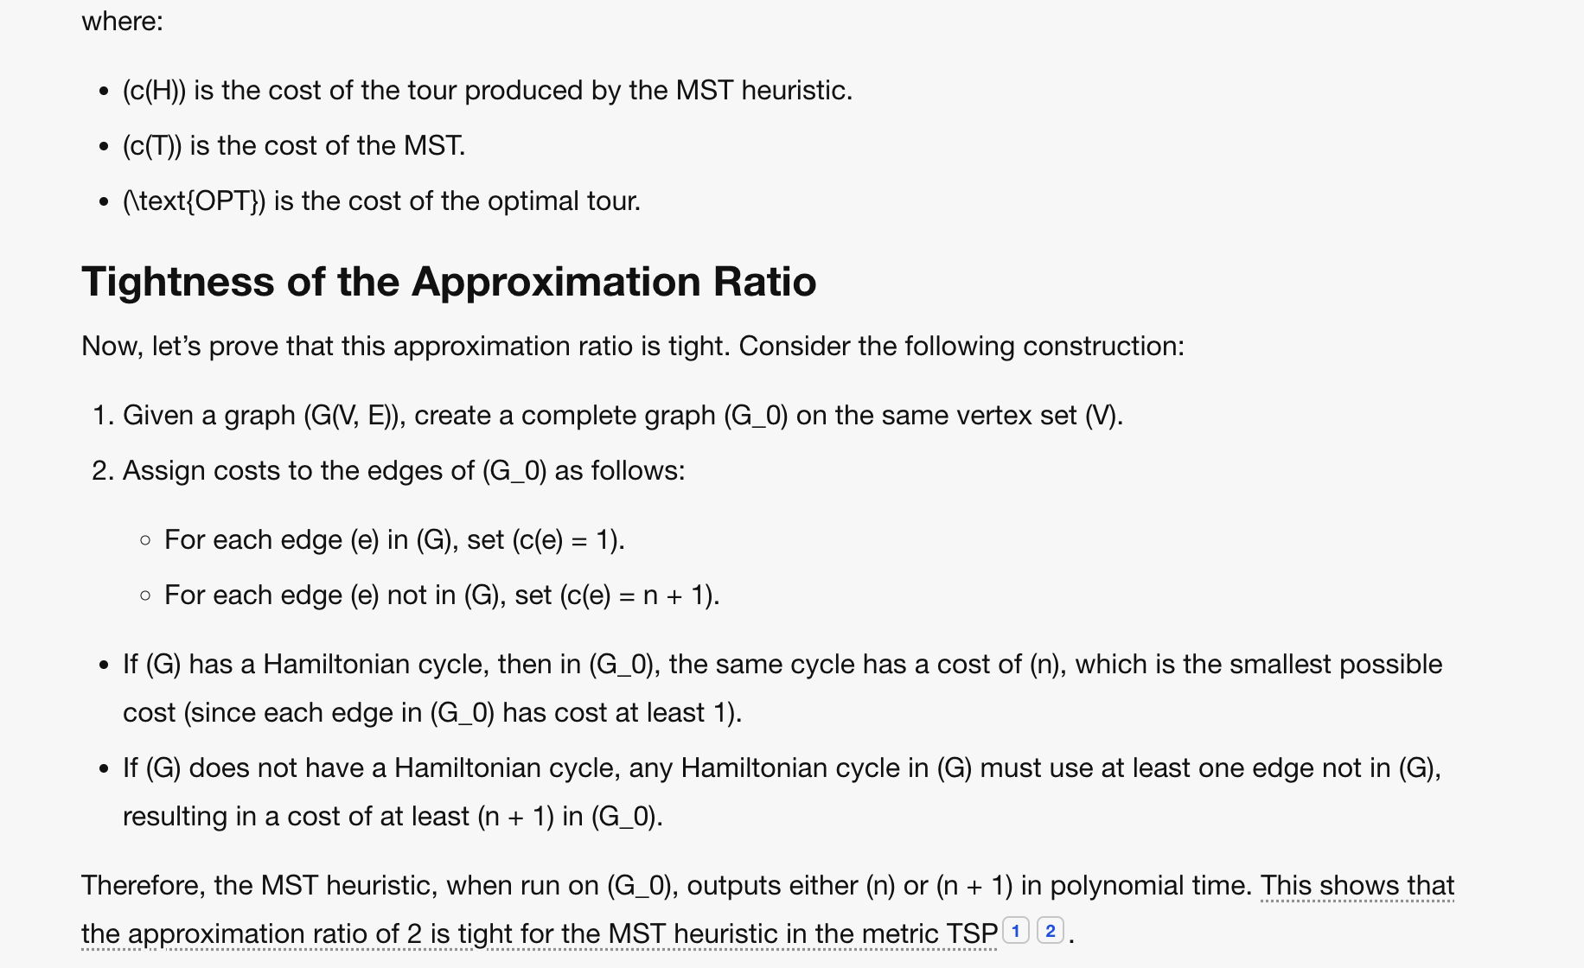

## Problem 2

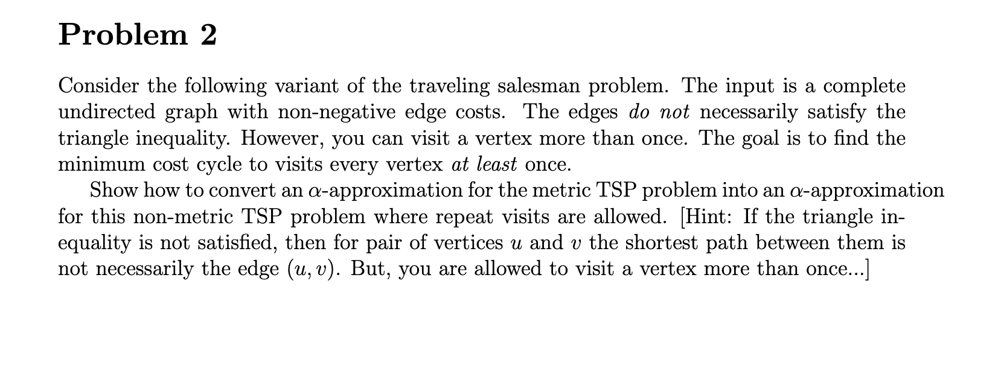

<https://theory.stanford.edu/~trevisan/cs261/lecture03.pdf>

